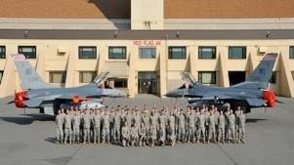

11
^{th}

Annual Military Appreciation Ride

January 20
-
21
,
2019

World Championship Derby Complex

Eagle River, Wisconsin

Help thank Wisconsin’s Combat Veterans
The Military Appreciation Ride Committee respectfully requests your consideration of a financial donation to help sponsor a very special snowmobiling event for Veterans. Your sponsorship of the Military Ride serves as a huge thank you to our Veterans who represent the 1% of the US population who serve in the US military. We hope you will join us as we take a day to thank not only our Wisconsin veterans for their service to our cities, state, and nation, but their spouses and children too - in a snowmobiling activity the whole family will enjoy.
What Your Donation Will Do:
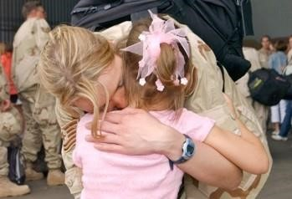
- Support and thank our nation’s veterans for their service through a fun, family activity to foster and improve their relationship(s) with his/her spouse, family, friends, and snowmobiling community.
- Grow the sport of snowmobiling by exposing our veterans to a safe and fun winter activity the entire family can enjoy.
- Educate and celebrate the camaraderie of snowmobiling to new and non-snowmobiling veterans and their families.
- Allow veterans to experience Wisconsin’s snowmobile trail system by introducing them to the volunteer efforts that create and sustain the biggest and best snowmobile trail system in the country!
Last year, over 114 Veterans/Family members rode between 65-125 miles! Annually average at least one Veteran family who buys a snowmobile (or two!), joins a local Club, and becomes new AWSC members! With your help, the 11th Military Appreciation Ride will be our best Ride to date. Thanks in advance for considering us.
Please THANK our 2018 Sponsors

Clubs
Arlington Prairie Drifters, Arlington
Back 40 Trail Riders, New Auburn
Baraboo River Runners, Baraboo
Bear Point Sno-Cruisers, Green Bay
Birchwood Bobcat Riders, Birchwood
Central Illinois Ditch Riders, Dawson, IL Cleveland Snow Hawks, Cleveland
Cozy Corner Trails, Danbury
Dun-Good Riders, Dunbar
Four-Dams Sno-Goers, Shawano
Greenleaf Riders, Greenleaf
Kumalong Sno-Riders, Peshtigo
Lake Country Riders, Siren
Louis Corners Sno-Birds, Kiel
Merrimac Snow Busters, Merrimac
Midnight Trail Riders, Green Bay
Near North Trail Riders of Athelstane
Northern Hornshoe Trails, Lac Du Flambeau
Northwoods Riders, Tomahawk
Poniatowski Dare Devils, Edgar
Ranger City Riders, Amberg
Sno-Eagles, Eagle River

Counties
Brown County Snowmobile Alliance
Burnett County Snow Trails Association
Clark County Snowmobile Council
Dodge County Assoc. of Snowmobile Clubs
Marinette County Snowmobile Alliance
Oneida County Snowmobile Council
Polk County Snowmobile & ATV Council
Sauk County Snowmobile Club Association
Vilas County Snowmobile Alliance

Businesses
Best Western Derby Inn, Eagle River
Boat Sport Marina, Eagle River
Decker Tours, Eagle River
Derby Complex, Eagle River
Don Rick Insurance, Baraboo
GARD Specialists, Eagle River
Ken’s Sports, Kaukauna
Leone’s Polaris, Peru, IL
Northernaire Resort, Three Lakes
Toy Shop, Eagle River
Track Side, Eagle River

State
AWSC – Assoc. of WI Snowmobile Clubs
American Legion Post 243, Plymouth

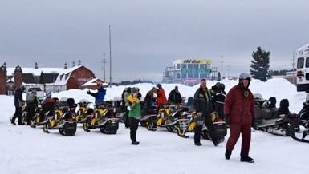
The 2019 Ride
Veterans will travel at their own expense to Eagle River on Sunday, January 20th, arriving by noon. The Derby Complex will provide complimentary tickets to all Veterans/family, so they can enjoy the 2019 World Championship Snowmobile Derby featuring the best professional snowmobile racers in the World! On Monday, January 21st, the excitement level will be sky-high as our Riders meet in the Derby Complex Expo Hall. Veterans who are new to snowmobiling will be provided a helmet and will learn to ride a sled provided by one of our fantastic local Dealers. All snowmobile riders will be split into groups based on level of experience and receive a trail safety briefing.
Our Guides take small groups of sleds on a 65-125-mile ride through some of Wisconsin’s most pristine trails in Vilas, Oneida & Forest counties. Groomers will ensure the trails are as smooth as a pool table; and, the camaraderie our Vets/Families enjoy on the trail and inside our pit-stops will truly be special.
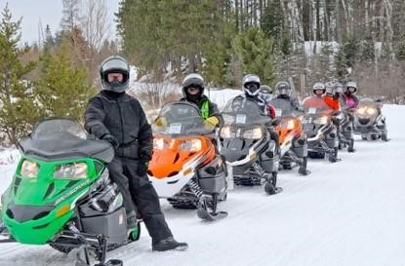
Most new or first-time snowmobile riders have no idea you can enjoy winter so much! Your support not only thanks our Vets, you’ll also help grow new snowmobiling families by introducing non-snowmobilers to a full and fun day of snowmobiling in Wisconsin!
Thanks in advance for your consideration. We simply would not be Some of our newbies able to honor these Vets without your kindness and support.
Who Can Attend?
The Military Ride is open to any and all Veterans:
Veterans who do not own snowmobiles*
- Tickets to the World Championship Derby
- Two nights of reduced rate hotel/lodging
- Complimentary lunch and dinner on January 21st
- The opportunity to ride a snowmobile including gas, oil, & snowmobile helmet

Veterans who bring their own snowmobile:
- Tickets to the World Championship Derby
- Two nights of reduced rate hotel/lodging
- Complimentary lunch and dinner on January 21st

* Apply early, as there are a limited number of snowmobiles for Veterans who are new Riders.

SPONSOR LEVELS:
Bronze $100
Silver $200
Gold $500
Diamond $750
Platinum $1,000
Corporate $1,500

Please make check payable to:
2019 Military Appreciation Ride
Mail to:
2019 Military Appreciation Ride
7158 S Devils Lake Dr
Webster, WI 54893
Email or call to get your Military Ride Application:
Email: military.ride@gmail.com
Phone: (608) 345-1819

